**TEMPLATE with instructions for a pre-study - project descriptions within the field of Strategic Vehicle Research and Innovation (FFI).**

The total number of pages in the project description should not exceed 5 (excluding summary, cover page, table of contents) in font size 11.

The project description constitutes the primary basis for assessing and reviewing an application.

Applicants are recommended to read the FFI programme road maps, call texts and instructions how to apply and report and other information that can be found on the FFI website, <https://ffisweden.se/en>, before writing their applications.

The applications that meet the formal requirements will be evaluated against the assessment criteria by an extern quality review group, who are appointed by Vinnova. The application is assessed in competition with other applications received. The review group adheres to professional secrecy as if they were under the employment of the agency.

*Tips and information are written in this format. You should delete the tips and this page before submitting your document.*

**Pre-study Application within FFI <*Programme name*>**

**<Insert the title of your project here>**

# Potential

*Describe the following:*

Your text here...

* the project's potential to contribute to the focus of the call

# External monitoring/state-of-the-art

Your text here...

*Briefly describe the level of knowledge in the area on an international and national level, and how the project relates to this knowledge. If deemed relevant, also describe how the project relates to state-of-the-art research in the field of study.*

# Feasibility **Project content**

Your text here...

Describe the content and setup of the project.

Also describe working and research methodology (scientific hypothesis and methods where it is relevant).

Then give a more detailed description of the contents of each respective activity/work package and specify who does what. Feel free to use the format below:

|  |  |
| --- | --- |
| **<Work Package (WP) no X>** | **<Name of activity/work package (WP)>** |
| Leader (role and responsibility) |  |
| Other participants (roles and responsibilities) |  |
| Description of contents |  |
| Method/approach (when relevant) |  |
| Delivery and evaluation |  |

## Scheduling

Your text here...

*Specify a timetable for the project that shows start and end dates along with important activities/work packages. A simple Gantt-chart should be provided.*

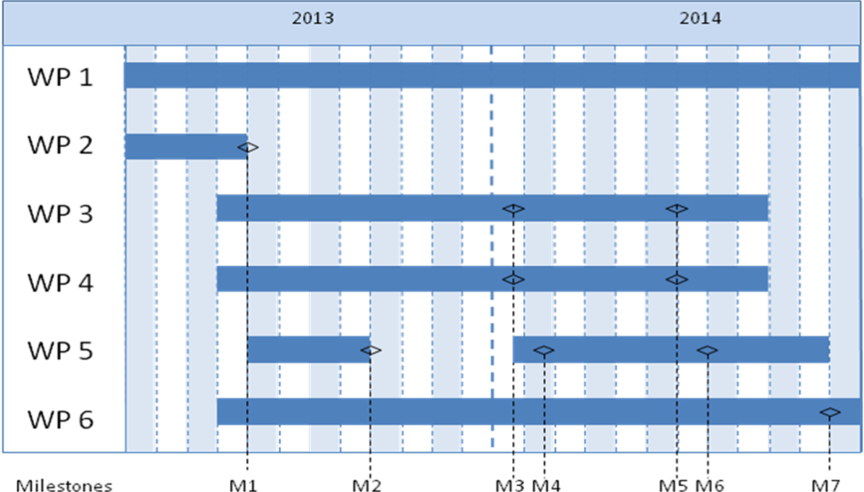

## Project financing

Your text here...

*The project financing per work package should be presented in the table below.*

|  |  |  |  |  |  |  |  |
| --- | --- | --- | --- | --- | --- | --- | --- |
|  | | Budget per participating party | | | | | Total budget/WP |
|  | | <Party 1> | | <Party 2> | | <Party X> |  |
| <WP1> | |  | |  | |  |  |
| <WP2> | |  | |  | |  |  |
| <WPx> | |  | |  | |  |  |
| TOTAL budget per part |  | |  | |  | |  |

*Personnel costs and wages for universities could be based on full actual costs where indirect costs must be presented separately.* *The industry may have indirect costs of a maximum of 30% of wage costs. These must be reported separately.*

Describe how the project aims to realise the potential of spreading/utilizing the results

# Actors

Your text here….

*CV (a template is available at vinnova.se/ffi) needs to be submitted for the project manager, work package leaders and other key personnel so that the project participants competence and abilities can be assessed.*

*Other relevant information about the parties can also be submitted here.*

*If subcontractors are to be procured (for example consultants) this must be specified along with the purpose and extent of their involvement in the project.*

# Equality

Your text here….

*Many problems, results and solutions can seem to be gender neutral, but they still affect women and men differently. How do you intend to take this into account in this project and how can it affect the project's effects?*

* *Describe how the project team is composed regarding gender distribution, but also the distribution of power and influence between men and women.*
* *Describe how equality aspects have been integrated in the project.*
* *Describe equality aspects (gender and gender perspective) that can be important to take into consideration in relation to the projects field of study, solutions, and effects.*

# References

*List your references (scientific publications, monographs, conference articles etc.) here. Be restrictive when referring to websites as these have not been “quality reviewed” in the same ways as a publication and the addresses tend to quickly become obsolete.*

The “References” section can be omitted if it is not needed.