TEMPLATE for project description for the call: Collaboration with China on research, development and innovation in the areas of life science, traffic safety and applied ICT.

This annex may comprise no more than 12 A4 pages, use Times New Roman font, 12 points. The document must be attached as a supplement to the application form at the Vinnova eServices Portal.

Please note that the project description must only deal with the Swedish part of the project (Swedish actors), as it is they who are applying for funding from Vinnova. The involvement of the Chinese partners should be included in the joint project plan (Coordinated Project Plan) and attached as an annex to your application.

This page and information in italics should be deleted before you submit your application. Leave the questions in place and do not make any changes in the margins.

Project description

Project title:
Enter the project title.

Describe the project in 2-3 sentences that may be used in a press release on funded projects.

The application applies to the following areas:

Life Science
☐ Infection prevention and antimicrobial resistance
☐ Personalised health and precision medicine
☐ Traditional Chinese medicine
☐ Prevention and treatment of cancer and cardiovascular disease
☐ Digitalisation in health care

Traffic safety
☐ Data collection and technology for in-depth analysis of road traffic accidents and road users.
☐ Advanced technology and equipment for the emergency services and responses to traffic accidents
☐ Safety of battery systems for vehicles with new energy sources, focusing on the management of heat development
☐ Safety of intelligent and connected vehicles

Applied ICT
☐ Automotive electronics
☐ Mobile health and intelligent medical technology, activated by the Internet of Things
☐ Real-time operating system (RTOS)
☐ The Internet of vehicles

Project description
Provide a description of the project, including background, problem and potential solution. Explain the importance of collaboration with China.

- Describe clearly which problem(s) and needs the project wants to address (who, what, when, why), and their scope.
- Describe any hypotheses/research questions.
- Describe the conceptual solution to the problem and the need (how).
- Explain the importance of undertaking this project together with Chinese partners.
- How will the project strengthen collaboration between Swedish and Chinese actors through research, development and innovation, and ultimately result in sustainable growth, increased safety and better health?

Level of innovation and news value
What makes the project unique and why is your solution the best one for the problem identified?

- Provide a description of the current international status/external analysis.
- Describe the project’s level of innovation, i.e. what is being done today to meet the need that you have identified and why is your intended solution new, unique and better?
- Does the project result in new knowledge or existing knowledge being implemented in a new context?

Agenda 2030
In what way will the project results contribute to achieving the sustainable development goals of Agenda 2030?

- Which interim goals will the project address?
- What is the potential of the project to contribute to increased sustainability?
- Discuss what negative effects the project may have in relation to Agenda 2030.

Gender equality
Describe how the project will work on this and how your solution will contribute to greater gender equality and equal opportunity.

- What is the gender distribution in the project team, among collaborative partners and in the target groups?
- How will women and men respectively be able to influence the project’s implementation and results or be affected by its solutions?
- What is the potential of the project to contribute to greater gender equality?

Potential
Describe the social and market potential of the project and the international competitiveness of the solution that the project is planning to develop. Also describe the potential to increase research and innovation competence in Sweden.

- Describe how the project contributes to economic value and benefit for society and for Sweden.
- How will the results of the project be used, disseminated and further developed after the end of the project?
- In what way does the project being run together with a Chinese partner increase the potential?
- If your solution is to be commercialised;
  - How do you plan to do this?
  - What is the intended market and who is the intended customer for the solution?
  - What is the expected market potential?
  - Describe your competitive position and competitive strength.
  - What are the IP rights at present for the intended solution?
  - What regulatory challenges do you see before you and how are these being handled?

Actors and project management
Describe the roles of the different national actors in the project and their competence to contribute to a successful project. Describe how the needs owners/customers contribute to the development of the solution (i.e. those who are to benefit from the solution and those who are paying for the solution). Please complete the table below for all companies that are project partners in the application.

Company:
Year of registration for the company according to the Swedish Companies Registration Office:
Is the company part of a group, if so which:
 | 2018 | 2017 | 2016
Number of employees in the company
The company’s net sales
The company’s profit/loss

- Describe how project management is to be organised.
- Describe all project partners in the project.
- Explain the involvement of the different parties in the project and describe the strengths of each party.
- Explain the partner constellation and describe any link between the project partners.
- Are the needs owners represented in the partner constellation or project implementation?
- If subcontractors are to be procured (e.g. consultants), this must be stated and the purpose justified, and the scope described.
- Other relevant information about the parties in the project may be provided here.

The CVs of project managers and other key personnel must be attached so that the project participants’ competence and ability to carry out the project can be assessed (templates are available on the call’s website).

Project implementation
Describe how the project is to be implemented, i.e. what you intend to do and how you intend to work. Complete the table below for all work packages in the project.

- Describe the project’s content and structure in general terms (more detailed description of work packages in the tables below).
- Also describe the methods and approaches used in the project (scientific level/clear hypotheses and test methods where relevant).
- Then provide a more detailed description of the content of each activity/work package and explain who is doing what. Use the structure as shown in the following example:

Work package (WP) no. X | Name of activity/work package (WP)
Person responsible (role and responsibility)
Other participants (role and responsibility)
Description of content
Method/approach (where relevant)
Deliveries

Scheduling
Describe the project schedule

Enter the project schedule showing start and end dates, important tasks/work packages and milestones, and when the different deliveries can be expected. It is a good idea to use a Gantt chart and a table with milestones as shown in the example below.

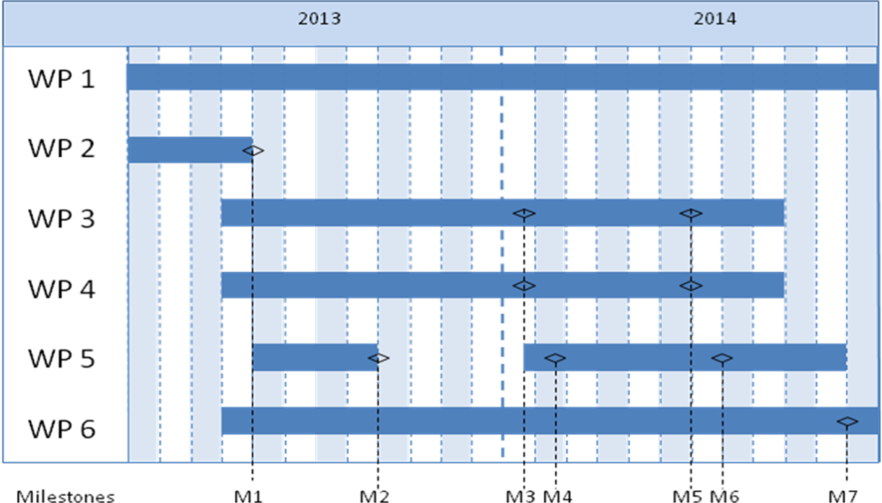

Milestone | Description | Date
M1
M2
M3
Mx

Project budget
Specify the project costs per work package and party in the table below.

 | Budget per participating party |  |  | Total budget/WP
 | Party 1 | Party 1 | Party x
WP1
WP2
WPx
Total

Risks and obstacles
What are the biggest risks to the project and its implementation? How are you going to deal with these?

- What do you perceive to be difficult and risky?
- Describe the risks (in words), consider the likelihood that they will occur.
- Explain how the risks will be managed.

Miscellaneous
If there are any other aspects of your project that do fall under the above headings, please describe them here.

