TEMPLATE for project description for the call for proposals: Collaboration with China regarding research, development and innovation within life science and road traffic safety.

The project description may cover a maximum of 10 pages in 11 point font.

Please note that the project description will only cover the Swedish part of the project (Swedish players) as they are the ones who are applying for funds from Vinnova. The participation of the Chinese parties is included in the coordinated project plan as an appendix to your application.

This page and calls for proposals in italics must be deleted before you submit your application.

Project description

Project title:

The application relates to the following area:

Life Science
☐ Infection prevention and anti-microbial resistance
☐ Individualised health and precision medicine
☐ Traditional Chinese medicine
☐ Digitalisation within care

Traffic safety
☐ Technology for in-depth analysis of road traffic accidents
☐ Analysis of the behaviour of vehicle drivers and vulnerable road-users
☐ Advanced technology and equipment for rescue services and efforts in the event of road traffic accidents

Background and description of current situation
Your text here...
- Describe clearly what problem(s)/need(s) the project is intended to solve, as well as their extent.
- Describe hypotheses/research questions.
- Provide an international state of the art of the area in question.

Originality and news value (uniqueness)
Your text here...
Describe the originality and news value of the project, e.g. that new knowledge is being developed or that existing knowledge is being implemented in a new context, as well as how this relates to the international state of the art.

Market and social potential
Your text here...
Describe how the anticipated results will be utilised both within and outside of the participating companies, authorities, universities and institutes.
- How will the project results be disseminated?
- Will the project result in new knowledge or in existing knowledge being implemented in a new context?
- Describe how the project is contributing to economic value. For example, that the project is resulting in new products and services that can be commercialised, for instance through improved health or the streamlining of care, or reduced injuries in traffic.

Project implementation
Your text here...
Describe the content and structure of the project in general terms (more detailed description of work packages in the tables below).
Describe also the methods and approaches that are used in the project (scientific altitude/clear hypotheses and test methods where relevant).
Then provide a more detailed description of the content of the activity/work package in question and describe who does what. Use structure in line with the following example:

<Work package (WP) no. X> | <Name of activity/work package (WP)>
Responsible (role and responsibility)
Other participants (role and responsibility)
Description of content
Method/approach (where relevant)
Deliveries

Scheduling
Your text here...
Specify the schedule for the project, showing start and end dates, important activities/work packages and milestones, as well as when the various deliveries can be anticipated. Feel free to use a Gantt diagram and a table detailing milestones according to the following example.

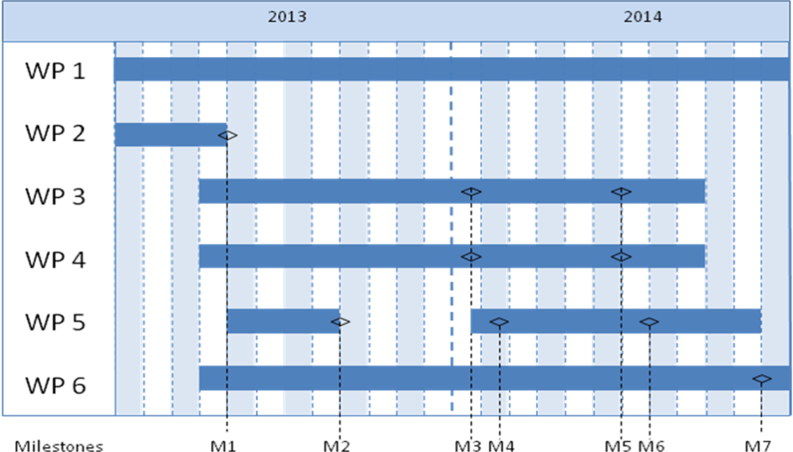

Milestone | Description | Date
M1
M2
M3
Mxx

Project finances
Your text here...
The project’s costs per work package and party must be presented in the following table.

 | Budget per participating party |  |  | Total budget/WP
 | <Party 1> | <Party 1> | <Party x>
<WP1>
<WP2>
<WPx>
Total

Players and project management
Your text here...
Describe how the project management is to be organised. Describe all the participants in the project (organisational level) and provide a brief description of the Chinese project participants. Give grounds for the participation of the various parties in the project and describe each party’s strengths. The international experience of the parties should also be specified, as should the role of the project participants in relation to the solution proposed by the international project group for the selected market.

Other relevant information about the parties in the project can be provided here.

If the intention is to engage subcontractors (e.g. consultants), this must be indicated and the purpose must be justified, as well the extent to which the subcontractors are to be used.

Gender equality
Your text here...
What is the gender distribution in the project team, among collaborative parties and in the target groups? How will women and men respectively be able to influence the project’s implementation, results and solutions? What potential does the project have to contribute to improved gender equality?

CVs must be attached for the project manager and other key individuals, so that the project participants’ expertise and ability to implement the project can be assessed (template can be downloaded for the call for proposals’ website).

