TEMPLATE with instructions for project descriptions within the field of Strategic Vehicle Research and Innovation (FFI).

Applicants are recommended to read our road maps, instructions how to apply and report and other information that can be found on the VINNOVA website, http://www.vinnova.se/sv/ffi/, before writing their applications. In the document “Applying and reporting FFI projects” the application process is described. All documents referred to in this template can be found on the website.

The project description constitutes the primary basis for assessing and reviewing the quality of an application.

The total number of pages in the project description should not exceed 15 (excluding cover page, summary, table of contents) in font size 11. Longer project description could be applied but must get a waiver in advance from the programme office. Otherwise, only the first 15 pages will be taken into account.

The application, including the project description, will initially be assessed by a quality review group consisting of independent experts and government employees. The application, including the project description is then assessed by the programme council. The programme council consists of representatives of the contracting parties in the FFI-programme (VINNOVA, the Swedish Energy Agency, the Swedish Transport Administration, AB Volvo, Volvo Cars, Scania and FKG). The programme council also includes a representative from Bil Sweden who does not, however, have a vote. The programme council presents its recommendation to VINNOVA, the Swedish Energy Agency or the Swedish Transport Administration, and the authority in question then makes a decision regarding funding. If the applicant objects to the programme council being given the project description (see page 2), the government agencies only allow the programme council to see the application, excluding the programme description, as well as the quality review group assessment/recommendation. Based on this information the programme council presents its recommendation to the government agencies.

Tips and information is written in this format. If you base your project description on this document, you should of course delete the tips and this page before submitting your document.

Application within FFI <Programme name>
<Insert the title of your project here>
Date:
Coordinator (name, e-mail, telephone):

Pre-Study Yes No

Full application Yes No

The applicant consents to the programme council being given
the complete application, including the project description. Yes No

This will be page 1 of your project description.

The coordinator is the person responsible for submitting the application and for subsequent communication and reports within the project.

Summary
Your text here...
The summary should be no longer than half a page.

The summary should specify
- Which problem is to be solved
- What the project is expected to achieve (what utility) and who is the intended user
- Which party is the main applicant (responsible for the application)
- Which other parties are participating in the project
- The period during which the project is expected to be conducted and at what cost (total cost and public funds)

Table of contents

Summary 3
Table of contents 4
Background and state-of-the-art 5
Originality and newsworthiness 5
Programme relevance 6
Objectives 6
Results 6
TRL classification 6
Utilisation of project results 7
Feasibility 8
Project contents 8
Scheduling 8
Project financing 9
Project management and project participants 9
References 9

Right-click the table of contents to find the function for updating contents and page numbers.

You have three levels of headings at your disposal (Heading 1, 2 and 3).

Background and state-of-the-art
Your text here...
Provide a background for the project, including the following information:
- clearly describe what/which problems or needs the project aims to address and the scope of the problems or needs
- describe hypotheses/research issues
- give a description of the current international state (“state of the art”) of the research/technology field and how the project relates to this. A list of references is placed last in the document.
- present ties to other projects that may speed up the introduction of new solutions or increase the impact of the project?
- if the project is a continuation, describe obtained results and their connection and how this project will be affected
- if the project is a continuation of a previous project, also state
Project number:
Title:
Programme affiliation:
Decision-making agency:
Summary of results and conclusions:

If not, delete this table.

Originality and newsworthiness
Your text here...
Describe the project's originality and newsworthiness in the relevant field of application, for example, new knowledge being produced or existing knowledge being implemented in a new context, and how it relates to the current international level of knowledge.

Programme relevance

Objectives
Your text here...
Explain why the project is important to the FFI programme.

- Describe how the proposed project will contribute to one or more of the overarching FFI objectives:
  - increasing the Swedish capacity for research and innovation, thereby ensuring competitiveness and jobs in the field of vehicle industry
  - developing internationally interconnected and competitive research and innovation environments in Sweden
  - promoting the participation of small and medium-sized companies
  - promoting the participation of subcontractors
  - promoting cross-industrial cooperation
  - promoting cooperation between industry, universities and higher education institutions
  - promoting cooperation between different OEM
- Describe how the project contributes to one or more of the sub-programme objectives stated in the description of each respective sub-programme.
  - Describe which of the sub-programme research fields is/are most relevant to the project.
  - Also describe how the project relates to the sub-programme road map, , see the FFI website, http://www.vinnova.se/sv/ffi/.
  - If possible, specify concrete and measurable objectives for the project (for example, x % reduction in energy consumption or reduction in fatal road accidents).
  - Describe the assessment/follow-up of the project in terms of the set objectives.

Results
Your text here...
Describe the expected result and what concrete “deliveries” the project will contribute. This may include:
- development of methodologies or models
- skills creation
- development of prototypes
- licentiate or doctoral thesis
- demonstration plants or installations
- Production changes etc...

TRL classification
Your text here...
Describe what technology that the project are planned to develop, what start level and end level. Normally, projects between TRL 2 and 7 are in the FFI programmes scope. Larger than 3 TRL-jumps should be motivated clearly. The description should be both in word and with a figure according to the table below. If several technologies are addressed in the project, the different parts should be described separately. In the document “To apply and report FFI projects” the TRL levels are explained and also the corresponding MRL-levels are described.

Erase the table.

Phase | TRL | Signs of achievement | Examples of the maturity level to achieve
Implementation | 9 | The product is successfully used  (verified product use) | The product has been introduced on the market and the technology has been proven to work in actual use.
Pilot and demonstrator projects | 8 | The complete system has been validated | Tests and demonstration phase complete to the satisfaction of potential clients. The technology has found its final format, performance has been verified.
 | 7 | Demonstration in operating environment | The technology has been proven to work in tests with prototype or demonstration vehicle in an actual operating environment. Hand over to product development.
 | 6 | Demonstration in relevant environment | The system, or a larger subsystem, has proven to work under conditions resembling reality (for example at a testing track)
 | 5 | Technical validation in relevant environment | Components or subsystems have been tested in conditions resembling reality (such as testing rig or testing vehicle). The viability of the technology has been proven.
Technical research | 4 | Technical validation in laboratory environment | Components or subsystems have been tested.  The relationship of the concept to other systems (such as in a complete vehicle) has been determined.
 | 3 | Experimental proof that there is potential in the concept | Analytical or experimental studies have been conducted. The characteristics of the technology are known.
 | 2 | Formulation of technological concepts | Possible applications have been determined.  Fundamental principles are studied. Refined predictions of performance.
Basic research | 1 | Observation of basic principles | Scientific results are available to indicate a possible practical application. Possible to estimate performance.

Utilisation of project results
Your text here...
Describe how the expected results will be utilised both within and outside of the participating companies, government agencies, universities and higher education institutions.
- How will the project results be disseminated?
- Will the project lead to new knowledge, or to existing knowledge being implemented in a new context?
- Describe if the project will be a part of a larger content or cluster or if cooperation is planned with other initiatives, programmes or projects.
- Indicate in the table below how the project results are directly intended to be used or passed on:

Increase knowledge in a specific area
Be passed on to other advanced technological development projects
Be passed on to product development projects
Introduced to the market
Used in investigations, regulations, permit matters/political decisions.
Select the time perspective of results from the project has:

Short term (challenging project, possible introduction about 2-4 years after the completion of the project)
Medium term (knowledge-building project, possible introduction 5-8 years after completion of project):
Long term (enabling new technology, possible introduction at the earliest 8 years after completion of project)

Feasibility

Project contents
Your text here...
Describe the content and setup of the project. The description should embrace different work packages content, role and responsibility of leaders and other participants, defined deliverables/milestones and TRL-levels.

Also describe working and research methodology (scientific hypothesis and methods where it is relevant).

Then give a more detailed description of the contents of each respective activity/work package and specify who does what. Feel free to use the format below:

<Work Package (WP) no X> | <Name of activity/work package (WP)>
Leader (role and responsibility)
Other participants (roles and responsibilities)
Description of contents
Method/approach (when relevant)
Delivery

Scheduling
Your text here...
Specify the project time schedule, start and end dates, showing important activities/work packages and milestones, as well as when different deliveries can be expected. A simple Gantt diagram and a table of milestones, as shown in the example below, may be helpful.

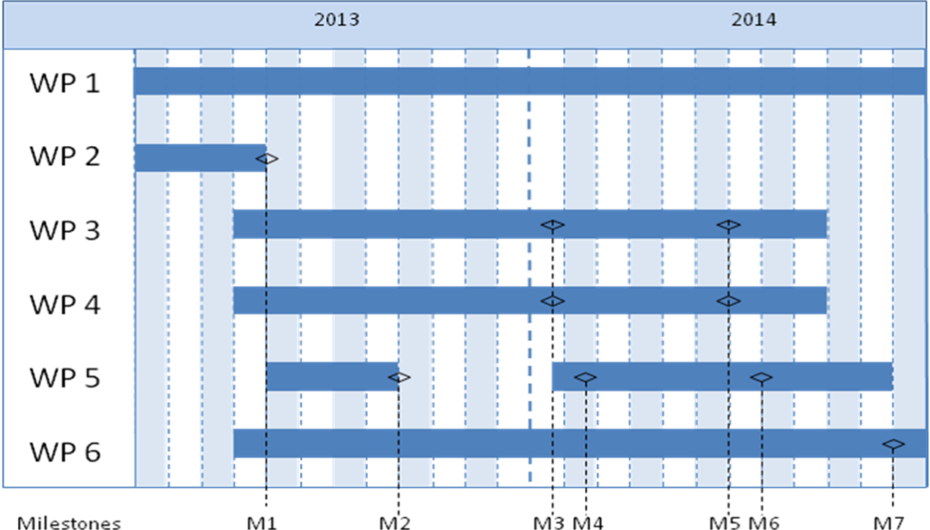

Milestone | Description | Date
M1
M2
M3
Mxx

Project financing
Your text here...
The project financing per work package should be presented in below table. The projects costs should also be presented by its cost kind in the Budget project form (excel template).

 | Budget per participating party |  |  | Total budget/WP
 | <Party 1> | <Party 1> | <Party x>
<WP1>
<WP2>
<WPx>
TOTAL

Personnel costs and wages for universities could be based on full actual costs where indirect-costs must be presented separately. For further information see “Applying and reporting FFI projects”.

Project management and project participants
Your text here...
Describe the organisation of the project management. If there is a specific budget for project management, this should also be specified. Also describe any steering groups or reference groups.

CV (template can be found on the VINNOVA website) should be enclosed for the coordinator and other key persons so that the project participants' expertise and ability to carry out the project can be assessed.

Other relevant information regarding the project participants and the composition of the work group, which is not included in the CV.

If subcontractors are to be included in the project, please note this and give also the purpose of using them including the magnitude of their participation.

References
List your references (scientific publications, monographs, conference articles etc.) here. Be restrictive when referring to websites as these have not been “quality reviewed” in the same ways as a publication and the addresses have a tendency to quickly become obsolete.
The “References” section can be omitted if it is not needed.

