FULL APPLICATION

TEMPLATE with instructions for project descriptions within the field of Strategic Vehicle Research and Innovation (FFI).

The total number of pages in the project description should not exceed 15 (excluding cover page, summary, table of contents) in font size 11. If a longer project description is needed the applicant must contact the programme-management to obtain special dispensation.

The project description constitutes the primary basis for assessing and reviewing the quality of an application.

Applicants are recommended to read the FFI roadmap and other information that can be found on the VINNOVA website, http://www.vinnova.se/sv/ffi/, before writing their applications. All documents referred to in this template can be found on the website.

The application will be assessed by the programme advisory board and an external quality review group appointed by VINNOVA, the Swedish Energy Agency or the Swedish Transport Administration. The review group adheres to professional secrecy as if they were under the employment of respective agency. If the applicant objects to the programme advisory board being given the project description (see page 2), the government agencies only allow the programme advisory board to see the application, excluding the programme description, as well as the quality review group assessment/recommendation.

This page along with tips and information written in cursive format should be deleted before submitting your application.

Application within FFI <Programme name>
<Insert the title of your project here>
Date:
Coordinator (name, e-mail, telephone):

The applicant consents to the programme advisory board being given
the complete application, including the project description.

Yes No

Is it a reworked application that has previously been assessed by the FFI quality review group?
Yes No

If yes, specify the reference number:

This will be page 1 of your project description.

The coordinator is the person responsible for submitting the application and for subsequent communication and reports within the programme.

Summary
Your text here...
The summary should be no longer than half a page and specify:

- Which problem is to be solved and its connection to the subprogrammes mission as it is described in the FFI roadmap
- What the project is expected to achieve (what utility) and who is the intended user
- Which party is the main applicant (responsible for the application)
- Which other parties are participating in the project
- The period during which the project is expected to be conducted and at what cost (total cost and public funds)

Table of contents

Summary 3
Table of contents 4
Background and goals for the project 5
Potential 5
External monitoring/state-of-the-art 6
Feasibility 7
Project contents 7
Scheduling 7
Project financing 8
Utilization 8
Actors 8
Equality 8
References 9

Right-click the table of contents to find the function for updating contents and page numbers.

You have three levels of headings at your disposal (Heading 1, 2 and 3).

Background and goals for the project
Your text here...
- Provide a background for the project and clearly describe what/which problems or needs the project aims to address and the scope of the problems or needs, describe hypotheses/research issues. If possible, specify concrete and measurable objectives for the project (for example, x % reduction in energy consumption or reduction in fatal road accidents).
- Describe the projects innovation level within the relevant field of application, for example that new knowledge is produced or that current knowledge is applied in new contexts

Potential
Your text here…

Describe the following:
- The projects potential to contribute to FFI:s overarching impact goals:
  - FFI has demonstrated solutions that make society's road transport fossil-free, safe, equal, and efficient.
  - FFI has developed sustainable solutions that have been implemented and accepted by users and society.
  - FFI has contributed, through innovation, partnerships, and collaboration, to the development of skills, infrastructure, policy, regulatory frameworks and business models in the road transport system.

- The projects potential to contribute to the sub-programmes mission as it is described in the FFI roadmap.
- The projects potential to develop internationally connected research- and innovation environments.
- The projects contribution towards hastening the implementation that is needed to, in the long term, achieve the sub-programmes mission as it is described in the FFI roadmap.
- If the project refers to a mature field of study, does the project lead to large potential improvements in line with the vision in the FFI roadmap?

External monitoring/state-of-the-art

Your text here...
Give a description of both how project stems from solid external monitoring and how it relates to the current international state (“state of the art”) of the research/technology field.
A list of references is too be placed last in the document.

If the project is a continuation of a previous project, clearly state what results have been achieved and how they are used and influence the continuation project. If there is a final report available, it can be submitted as an attachment. Also state the following:
Project number:
Title:
Programme affiliation:
Decision-making agency:
Summary of results and conclusions:

If not, delete this table.

Feasibility

Project contents
Your text here...
Describe the content and setup of the project. The description should embrace different work packages content, role and responsibility of leaders and other participants and defined deliverables/milestones. Describe how the work packages will be evaluated against the set goals.

Also describe working and research methodology (scientific hypothesis and methods where it is relevant).

Then give a more detailed description of the contents of each respective activity/work package and specify who does what. Feel free to use the format below:

<Work Package (WP) no X> | <Name of activity/work package (WP)>
Leader (role and responsibility)
Other participants (roles and responsibilities)
Description of contents
Method/approach (when relevant)
Delivery and evaluation

Scheduling
Your text here...
Specify the project time schedule, start and end dates, showing important activities/work packages and milestones, as well as when different deliveries can be expected. A simple Gantt diagram and a table of milestones, as shown in the example below, may be helpful.

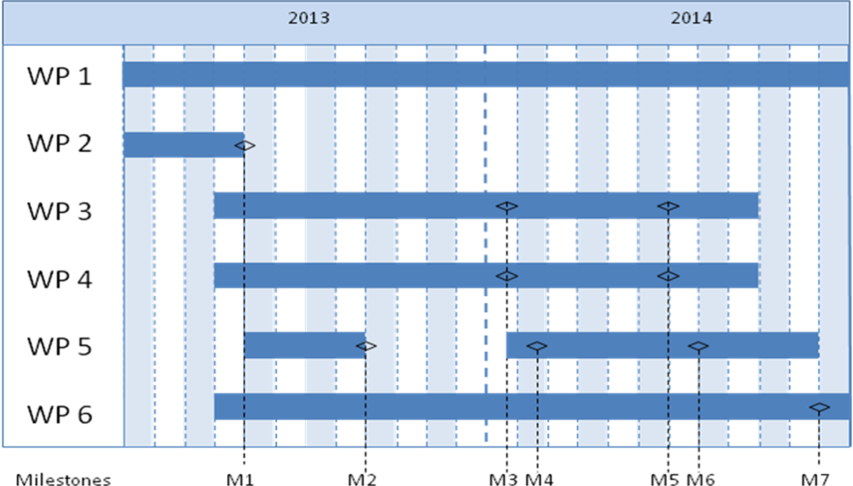

Milestone | Description | Date
M1
M2
M3
Mxx

Project financing
Your text here...
The project financing per work package should be presented in the table below. The projects costs should also be presented by its cost kind in the Budget project form (excel template).

 |  | Budget per participating party |  |  |  |  | Total budget/WP
 |  | <Party 1> |  | <Party 1> |  | <Party x>
<WP1>
<WP2>
<WPx>
TOTAL budget per part

Personnel costs and wages for universities could be based on full actual costs where indirect-costs must be presented separately.

Utilization
Your text here...
Describe how the project aims to realise the potential of spreading/utilizing the results

Actors
Your text here….
Describe how the project management will be organized. Also describe eventual steering- and reference groups.

CV (a template is available at vinnova.se/ffi) needs to be submitted for the project manager, work package leaders and other key personnel so that the project participants competence and abilities can be assessed.

Other relevant information about the parties can also be submitted here.

If sub-contractors are to be procured (for example consultants) this must be specified along with the purpose and extent of their involvement in the project.

Equality
Your text here….
Many problems, results and solutions can seem to be gender neutral, but they still affect women and men differently. How do you intend to take this into account in this project and how can it affect the project's effects?

- Describe how the project team is composed regarding gender distribution, but also the distribution of power and influence between men and women.
- Describe how equality aspects have been integrated in the project.
- Describe equality aspects (gender and gender perspective) that can be important to take into consideration in relation to the projects field of study, solutions, and effects.

References
List your references (scientific publications, monographs, conference articles etc.) here. Be restrictive when referring to websites as these have not been “quality reviewed” in the same ways as a publication and the addresses have a tendency to quickly become obsolete.
The “References” section can be omitted if it is not needed.

