TEMPLATE with instructions for a pre-study - project descriptions within the field of Strategic Vehicle Research and Innovation (FFI).

The total number of pages in the project description should not exceed 5 (excluding cover page, summary, table of contents) in font size 11.

The project description constitutes the primary basis for assessing and reviewing the quality of an application.

Applicants are recommended to read the FFI programme road maps, call texts and instructions how to apply and report and other information that can be found on the VINNOVA website, http://www.vinnova.se/sv/ffi/, before writing their applications.

The application will be assessed by the programme advisory board and an external quality review group appointed by VINNOVA, the Swedish Energy Agency or the Swedish Transport Administration. The review group adheres to professional secrecy as if they were under the employment of respective agency. If the applicant objects to the programme advisory board being given the project description (see page 2), the government agencies only allow the programme advisory board to see the application, excluding the programme description, as well as the quality review group assessment/recommendation.

Tips and information is written in this format. You should delete the tips and this page before submitting your document.

Pre-study Application within FFI <Programme name>
<Insert the title of your project here>
Date:
Coordinator (name, e-mail, telephone):

The applicant consents to the programme council being given
the complete application, including the project description.

Yes No

Is it a reworked application that has previously been assessed by the FFI quality review group?
Yes No

If yes, specify the reference number:

This will be page 1 of your project description.

The coordinator is the person responsible for submitting the application and for subsequent communication and reports within the programme.

Table of contents

Summary and goals for the project 3
Potential 4
External monitoring/state-of-the-art 4
Feasibility Project content 4
Scheduling 5
Project financing 5
Utilization 6
Actors 6
Equality 6
References 7

Right-click the table of contents to find the function for updating contents and page numbers.

You have three levels of headings at your disposal (Heading 1, 2 and 3).

Summary and goals for the project
Your text here…
- Provide a background for the project and clearly describe what/which problems or needs the project aims to address and the scope of the problems or needs, describe hypotheses/research issues. If possible, specify concrete and measurable objectives for the project (for example, x % reduction in energy consumption or reduction in fatal road accidents).
- Describe the projects innovation level within the relevant field of application, for example that new knowledge is produced or that current knowledge is applied in new contexts

Potential
Describe the following:
- The projects potential to contribute to FFI:s overarching impact goals:
- The projects contribution towards hastening the implementation that is needed to, in the long term, achieve the sub-programmes mission as it is described in the FFI roadmap.
- If the project refers to a mature field of study, does the project lead to large potential improvements in line with the vision in the FFI roadmap?
Your text here...

External monitoring/state-of-the-art
Your text here...
Briefly describe the level of knowledge in the area on an international and national level, and how the project relates to this knowledge. If deemed relevant, also describe how the project relates to state-of-the-art research in the field of study.

Feasibility
Project content
Your text here...
Describe the content and setup of the project.

Also describe working and research methodology (scientific hypothesis and methods where it is relevant).

Then give a more detailed description of the contents of each respective activity/work package and specify who does what. Feel free to use the format below:

<Work Package (WP) no X> | <Name of activity/work package (WP)>
Leader (role and responsibility)
Other participants (roles and responsibilities)
Description of contents
Method/approach (when relevant)
Delivery and evaluation

Scheduling

Your text here...

Specify a timetable for the project that shows start and end dates along with important activities/work packages. A simple Gantt-chart should be provided.

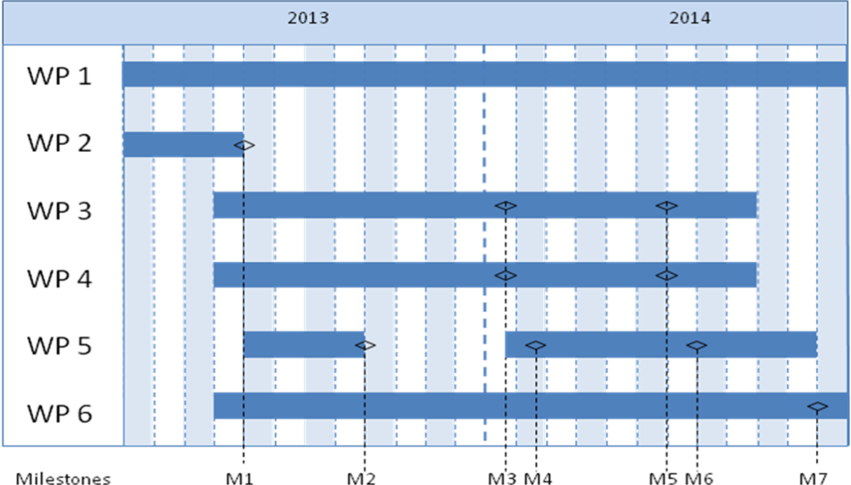

Project financing
Your text here...
The project financing per work package should be presented in the table below. The projects costs should also be presented by its cost kind in the separate budget form (excel template).

 |  | Budget per participating party |  |  |  |  | Total budget/WP
 |  | <Party 1> |  | <Party 1> |  | <Party x>
<WP1>
<WP2>
<WPx>
TOTAL budget per part

Personnel costs and wages for universities could be based on full actual costs where indirect costs must be presented separately.

Utilization
Your text here...
Describe how the project aims to realise the potential of spreading/utilizing the results

Actors
Your text here….

CV (a template is available at vinnova.se/ffi) needs to be submitted for the project manager, work package leaders and other key personnel so that the project participants competence and abilities can be assessed.

Other relevant information about the parties can also be submitted here.

If sub-contractors are to be procured (for example consultants) this must be specified along with the purpose and extent of their involvement in the project.

Equality
Your text here….
Many problems, results and solutions can seem to be gender neutral, but they still affect women and men differently. How do you intend to take this into account in this project and how can it affect the project's effects?

- Describe how the project team is composed regarding gender distribution, but also the distribution of power and influence between men and women.
- Describe how equality aspects have been integrated in the project.
- Describe equality aspects (gender and gender perspective) that can be important to take into consideration in relation to the projects field of study, solutions, and effects.

References
List your references (scientific publications, monographs, conference articles etc.) here. Be restrictive when referring to websites as these have not been “quality reviewed” in the same ways as a publication and the addresses tend to quickly become obsolete.
The “References” section can be omitted if it is not needed.

